State Differences in Light-Duty Vehicle Survival Rates
David L. Greene, University of Tennessee
Benjamin P. Leard, University of Tennessee
Arthur Yip, National Renewable Energy Laboratory
Ruixiao Sun, Oak Ridge National Laboratory
Ranjan Bose, Oak Ridge National Laboratory

January 28, 2025
Abstract
Transitioning to zero-emission electric vehicles (EV) is a complex and multidecadal process of systemic change. For the U.S., because of the large differences in EV adoption across states, an important component of the process is the movement of used vehicles and their rates of survival across the fifty states. This report describes a step towards creating a model of the stock of used light-duty vehicles with vehicle type, age, and state level detail. The used vehicle market is influenced by economic and demographic variables, but especially by the sales of new vehicles. These factors affect the uptake of used vehicles, their movements from state to state, and their rates of scrappage and survival. A state’s net survival rates, the combined result of migration and scrappage, are shown to depend on a variety of factors that vary by state and vehicle age, but especially employment, income and population migration. Using state level data on net survival rates for 2015-2022, survival models are estimated separately for passenger cars, sport utility vehicles (SUVs) and vans, and pickup trucks that successfully represent Important differences among states in net survival rates by vehicle age.

- Introduction and Overview
Motor vehicles dominate U.S. transportation, accounting for 87% of passenger-miles traveled and 40% of freight ton-miles, with light-duty vehicles representing 87% of all highway vehicles (USDOT/BTS, 2025). As technologies such as automation and electrification transform transportation, understanding vehicle market dynamics and their impacts on energy, the environment, and society is crucial (Leard and Greene, 2023). Used vehicles are particularly important because they constitute approximately 95% of vehicles in use and account for the vast majority of energy use and emissions (USDOT/BTS, 2025). The analysis presented in this report is intended to provide a foundation for building a state level model of the U.S. used vehicle market to be used in conjunction with a state-level new vehicle sales model for projecting the evolution of the U.S. vehicle stock and its composition, and how that evolution is affected by technological change and public policy. Geographically detailed motor vehicle models would be useful for understanding how demand for electricity and charging stations may evolve across the U.S. as EV adoption increases. As of the third quarter of 2024, all-electric vehicle (EV) plus plug-in hybrid electric vehicle (PHEV) market shares ranged from 27 percent in California, 26 percent in Colorado, and 25 percent in Washington state to 2 percent in Louisiana and West Virginia and North Dakota and 1.4 percent in Mississippi (AAI, 2025). The analysis presented below confirms that used vehicles do not stay put but migrate among states in response to economic and demographic changes and consumer preferences. Understanding the geographic dimensions of the EV transition could be useful for planning the expansion of charging infrastructure and electricity generation.
The remainder of this section is a brief overview of the theory of used vehicle supply and demand to provide context for the analysis of state vehicle survival rates. The following section describes the data to be used in estimating models of state survival rates and describes the approach to data analysis and model estimation. Section III presents an exploratory analysis of factors expected to affect state level net survival rates. Section IV describes our approach to modeling net survival rates for all fifty states by three vehicle types: passenger cars, sport utility vehicles (SUVs) and vans, and pickup trucks. Section V presents the results of the analysis and section VI discusses the implications for building state-level used vehicle models and remaining challenges.
Vehicle survival rates reflect the aggregated decisions of used vehicle owners to retain, sell or scrap their vehicles. The economic theory of motor vehicle scrappage dates back at least to Cramer (1958), who derived a statistical model of vehicle longevity. Cramer’s model assumed that vehicles would be scrapped when their value depreciated to zero either due to wear and tear or a sufficiently severe accident. The two key parameters of the model were the annual depreciation rate and the probability of a severe accident. Lacking data on vehicle mileage, depreciation was assumed to be solely a function of vehicle age. Walker (1968) introduced the effect of changes in used car prices, and noted that any significant repair could make the cost of restoring a vehicle to working condition greater than its market value. Parks (1977) derived a model of survival to age a+1 conditional on survival to age a, in which vehicles were scrapped when the sum of the cost of a repair plus the vehicle’s value as scrap exceeded its price. The size of repairs was assumed to be a random variable and an increasing function of vehicle age and a decreasing function of a vehicle’s inherent durability. Subsequent studies based on variations of the economic theories of vehicle survival developed by these authors are summarized in Greene and Leard (2024a).
The supply of used vehicles to the used vehicle market is not equal to the total number of existing used vehicles. Instead, used vehicle supply depends on the willingness of vehicle owners to sell their vehicles. Each year, t, a fraction of the vehicles in operation (VIO) n_{vat} of each age, a, and vehicle type, v, are offered for sale. The willingness of used vehicle owners to accept a price in exchange for their vehicles constitutes the supply function for used vehicles. As a simplification, we assume that each age and type (Car, SUV/vans, pickup) of light-duty used vehicle has its own supply function. In addition, we assume that the effects of population and income growth on used vehicle demand can be approximated by using elasticities to adjust base year demand. With that assumption, we focus on the effects of new vehicle prices and attributes on used vehicle prices. Consistent with the literature on motor vehicle scrappage, we assume that the fraction of used vehicles scrapped each year is a function of used vehicle prices (e.g., Walker, 1968; Parks, 1977; Greenspan and Cohen, 1999; Jacobsen and van Bentham, 2015; Alberini et al., 2018; Bento et al., 2018; Jacobsen et al., 2021).
The demand for used vehicles also depends on changes in the prices and attributes of new vehicles, because the attributes of used vehicles are fixed except for their depreciation with age and use. The equilibration of new and used vehicle supplies and demands determines the price of used vehicles in each year, p_{vat}. A change in new vehicle sales is assumed to be the result of a change in the generalized values of new vehicles. Generalized value, or generalized cost, is the monetized change in the utility of a vehicle. The effect of a change in new vehicle generalized cost relative to the base year is converted into a change in used vehicle price via an equilibrium elasticity of used vehicle price with respect to new vehicle price (e.g., Jacobsen et al., 2021). The changes in used vehicle prices, Δ_{vat} = p_{vat} – p_{v(a-1)(t-1)} , are used to estimate the change in a base-year scrappage function, r_{av} , by multiplying by the price elasticity of vehicle scrappage, α.
$r_{vat}^{*}=r_{vat}+α\frac{Δ_{vat}}{p_{v(a-1)(t-1)}}r_{vat}$ (1)
State level survival functions are equivalent to state level scrappage functions because scrappage rates, r, are one minus the corresponding survival rates, s. In equation (1), r_{vat} is the annual scrappage rate for vehicles of age a and type v in year t. It is defined as one minus the number of vehicles of type v of age a in year t divided by the number of vehicles of the same type of age a-1 in year t-1. The annual survival rate is 1-r_{vat}. In this report we estimate state-level models of annual survival rates from which scrappage rates follow.
The supply and demand for a vehicle of type v and age a depend on the prices of all other vehicle types and ages. However, little is known about the price elasticities of used vehicle supply and demand and even less is known about used vehicle cross-price elasticities (see, e.g., Jacobsen et al., 2021). However, if at market equilibrium the elasticities of used vehicle prices with respect to the price of new vehicles are approximately equal for all ages, and the own price elasticity for each age is approximately equal to the sum of the cross-price elasticities across other ages, the cross-price effects will be negligible.
Survival functions, together with necessary elasticity parameters are foundational components of a state-level used vehicle model (UVM). Given state-level survival functions, a state-level UVM can be implemented using the best available evidence on elasticities of used vehicle supply demand and scrappage, state-level vehicle counts by type and age. However, estimating state level used vehicle market dynamics will not necessarily result in a national market equilibrium. At this point, as a practical matter, it is not known whether the sum of state estimates will produce a reasonable approximation to a national solution. If not, a method for estimating an equilibrium solution for the national used vehicle market will be needed. A national solution could be imposed, for example, by requiring that the sum of net state deviations from estimated national vehicle survivals equal zero for all vehicle types and ages. Since the adequacy of unconstrained state estimates can only be determined empirically, this is an area for future research. This report describes the estimation of state level scrappage functions using state level survival rates by age and vehicle type without a national constraint.

- Data
Annual conditional vehicle survival rates are the probability that an a-year-old vehicle in year t will survive to become an a+1-year-old vehicle in year t+1. Cumulative survival rates are the probability that a new vehicle will survive to a given age a and are the product of annual conditional survival rates up to age a. State level annual survival rates (N_{vat}/N_{v(a-1)(t-1)}) for U.S. light-duty vehicles were provided by the National Renewable Energy Laboratory (NREL) for the years 2015/2014 to 2022/2021, by three vehicle types: passenger car, SUV and van, and pickup truck. The vehicle counts from which the survival rates were calculated are proprietary data purchased from Experian®. The numbers of vehicles in operation were measured as of December 31 of the year. Thus, the ratio for 2021/2020 reflects changes that occurred during calendar year 2021. The survival rates are based on a total census of vehicles in operation in each state derived from state vehicle registration data. However, the specific vehicle counts used to calculate the survival rates were not available for this analysis.
Using vehicle attributes available in the original database, NREL grouped vehicles into three types: passenger cars, SUVs and vans, and pickup trucks. The vehicle attribute data are considered highly accurate since they are based on unique vehicle identification numbers (VIN). Previous analysis of vehicle scrappage and survival have shown meaningful differences in survival functions for the three vehicle types (Greene and Leard, 2024a). However, changes in the nature of the vehicles in each class over time will undoubtedly have some effect on the fit of the models to vehicles of different ages.
We call the observed state survival rates “net survival rates” because they include the effects of vehicles that are permanently retired from service (scrapped), R_{ivat}, plus the migration of vehicles into, I_{Ivat}, and out of, E_{ivat}, a state i. The data do not distinguish between differences in survival rates due to migrations of vehicles among states versus differences due to actual scrappage. The observed state survival rates, reflect only the net effect of migration and scrappage, which we refer to as net state survival rates, s_{ivat}.
$s_{iva+1t+1}=\frac{N_{ivat}-R_{ivat}+I_{ivat}-E_{ivat}}{N_{ivat}}$ (2)
State net survival rates are more variable than national survival rates because state-to-state differences in retirement rates tend to offset each other to some degree at the national level, and because except for the relatively small number of used vehicles entering and leaving the U.S., vehicle migrations among states would sum to zero. Figure 1 shows all the (unedited) state net survival rates in gray dots and the national survival rates in black dots. In addition to the greater variance of the state net survival rates, several features of the data are worth noting. There are clearly anomalies that will be discussed later in the paper. For example, the three lines of state level dots well above the other data points from ages 1 to 30 years are the three vehicle types from the state of Tennessee in 2015. On the other hand, the lowest survival rates for vehicles greater than thirty years old, both national and state, are for the year 2021 and apparently reflect the unique effect of the COVID epidemic. Survival rates decline for the first 20-25 years, but then increase as older vehicles transition from utilitarian means of transportation to vintage collectors’ items. Finally, the variance of the state net survival rates increases with vehicle age, particularly after 20 years, while the numbers of vehicles in operation decreases.
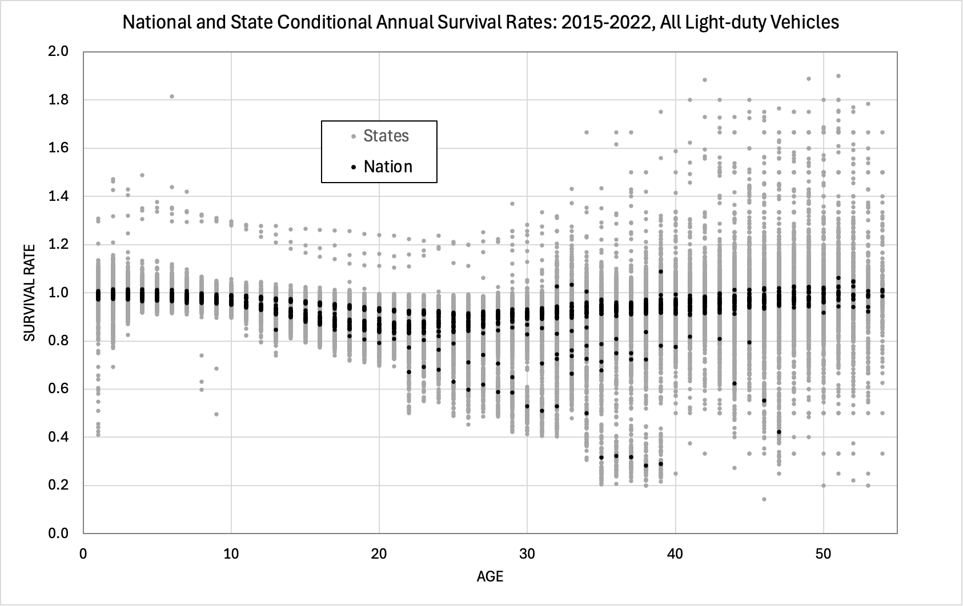
Figure 1. National and State Unedited Annual Survival Rates for All Light-duty Vehicles: 2015-2022
Our analysis comprises three phases. First, we graphed the state survival data to understand how state net survival rates differed from the national rates (the graphs can be found in Appendix B). Next, we explored correlations between net survival rates by age groups and variables that might plausibly cause differences among states by means of stepwise regression analysis. Finally, we used regression analysis to estimate state survival functions including continuous economic and demographic variables and fixed effects. In these estimations we hoped to quantify the effects variables that could be used to make long-run predictions of future rates, and to describe differences that are likely to persist over time or to reflect unique shocks, such as the COVID-19 pandemic.

- Exploratory analysis of Factors Affecting Net Survival Rates
Graphical analysis of cumulative survival rates revealed that state net survival rates differed in systematic and important ways from national survival rates (Appendix B). The graphs in Appendix B indicate that some states, especially in the southern, midwestern and western mountain regions have net survival rates higher than the national average, especially for newer used vehicles. Several exhibit net survival rates greater than 1.0 for newer vehicles, indicative of net immigration of newer used vehicles that exceeds scrappage rates. Other states, particularly in the Northeast, exhibit survival rates below the national average for younger used vehicles, suggesting that these states may be net exporters of newer used vehicles. Patterns vary from state to state and with vehicle age. Net vehicle survival rates in Utah and Idaho, for example, exceed the national rates over all ages. In California, net survival rates for younger used vehicles are close to the national rates but survival rates for older used vehicles exceed the national rates by a substantial margin.
An exploratory statistical analysis considered state-specific variables that might be correlated with state net survival rates. Average state survival rates weighted by an approximate estimate of the share of VIO were calculated for five age groups: 0-3, 4 to 9, 10 to 15, 16 to 25 and >25 years old. These groupings were chosen to represent different aspects of the used vehicle market. At two and three years, vehicles owned by rental companies and held by individuals on leases are typically offered for sale as used vehicles. New car dealers are most active in this market segment (Cox Automotive, 2021). Non-franchised used car dealers are most active in the market for 4 to 9-year-old vehicles. Online retail services are active in both markets. Although all types of used vehicle sales are present at all ages, beyond nine years, the used vehicle market is a mixture of used vehicle dealers, on-line sales and person-to-person transactions. As vehicle age increases, private sales become more frequent.
True scrappage (disposal) rates are very low for vehicles less than nine years old. Scrappage of the youngest used vehicles is typically caused by severe accident damage or other catastrophic events. Scrappage rates increase rapidly for vehicles from nine years old to 20 to 25 years of age and tend to decrease thereafter as vehicles increasingly become collectors’ items (Greene and Leard, 2024a). Therefore, we might expect differences in survival rates for younger used vehicles to reflect migrations of vehicles from one state to another. This could be caused by migrations of people or by differences in the demand for new and used vehicles among states. Differences in survival rates for vehicles aged 10 to 25 years, when survival rates decline fastest, should also reflect differences in wear and tear due to usage and environmental factors. By dividing the statistical analysis into age groups, we hoped to identify differences in the factors affecting net survival (scrappage plus migration) as vehicles age. Scrappage rates as a function of age have also been shown to vary by vehicle types (Greene and Leard, 2024a). We divided light-duty vehicles into the same three vehicle types as that study: passenger cars (PC), SUVs and pickup trucks (PU).
Deviations from the national survival rates for the same age categories for each of the three vehicle types were regressed against the set of candidate explanatory variables across the columns in Table 1 using the STATA™ forward stepwise regression procedure. Backward stepwise regression was also tried and produced similar results. The forward stepwise results tended to include more variables and statistically explain more variation. The explanatory variables are differences of state rates of change (e.g., annual population growth) minus the national rate of change to match the definition of the dependent variable. Thus, if income is growing faster than the national rate in a state, used vehicles may immigrate from states with lower rates of income growth to states with faster growth. Used vehicle prices in states with faster economic growth may increase relative to the national average, reducing state scrappage rates. Because survival rates for nearly new vehicles are high, we would expect the migration effect to dominate for newer used vehicles and the scrappage effect to increase in importance as vehicles age. The same reasoning applies to demographic variables. Appropriate annual data were not available for the Education, Wear & Tear, population density and rural population categories, for which data for 2017 or 2018 were used. A significance level of 0.1 was required for inclusion of a variable in the final models. Observations were unweighted because actual vehicles in operation counts were not available. Thus, scrappage rates for small states have as much influence as larger states and scrappage rates for older vehicles count equally with those of younger vehicles. Segmentation by age category tends to mitigate the fact that there are many fewer older vehicles.
For the youngest vehicles, only changes in demographic variables were statistically significant, except for salt use in the pickup regression, which might reflect a preference for 4-wheel drive vehicles in states where icy and snowy weather is frequent. In the 4-9-year-old group, driving age population growth and percent rural show up again and net survival rates for pickups are negatively correlated with population density, suggesting that used pickups might be migrating to states with lower population densities. Education and Wear & Tear variables show up for the first time: bachelor’s and advanced degrees are negatively associated with car and SUV net survival rates, and traffic fatalities (an indicator of severe crash damage) are negatively but less strongly correlated, as well. In the middle age groups the set of significant variables becomes more diverse, indicating that both migration and differences in scrappage rates are affecting net survival. Road salt application becomes strongly negatively associated with survival, as does the percent of population with advanced degrees, suggesting a preference for newer used vehicles in states with higher education levels. For the oldest vehicles, demographic and education variables drop out, economic factors remain positively associated with net survival rates, and wear & tear metrics appear but are difficult to interpret.

Table 1. Results of Stepwise Regression Analysis of State Deviations from National Scrappage Rates by Vehicle Type and Age Group
Note: Blue shading indicates positive coefficients, orange indicates negative. Three shades from darkest to lightest indicate statistical significance at 0.01, 0.05 and 0.10 levels. Use of stepwise regression invalidates the usual interpretation of significance levels as hypothesis tests. Instead, they should be interpreted as reflecting the strength of correlations.

These results indicate that differences in population and economic growth are positively correlated with net survival rates, which we interpret as chiefly reflecting migrations of vehicles from slower to more rapidly growing states. National conditional survival rates for vehicles 5-years-old or less are typically greater than 99 percent (Greene and Leard, 2024a). State net survival rates for younger used vehicles that are a few percentage points greater than 1 or less than 0.99 are likely to be due to migrations among states. Growth of the driving age population has the greatest impact up to age 9, while factors associated with increased scrappage, such as use of salt on roads and traffic fatalities appear to be strongest after age 9. In the models estimated below, we include state-to-state population migration as an explanatory variable, and it proves to be statistically significant. Economic variables are associated with increased net survival rates for vehicles 10 or more years old. Higher population density is negatively associated with net survival rates of 4-9-year-old pickups, suggesting a movement of relatively new pickups from urban to more rural states. On the other hand, a greater percentage of rural population is positively associated with net survival rates for passenger cars and SUVs, possibly indicating a migration of the newest used cars and SUVs to more rural areas. The negative effect of a greater proportion of people with bachelor’s degrees or higher on survival rates for 4-25 -year-old vehicles suggests a preference for newer vehicles among that group. More intensive vehicle use is generally non-significant, and the reason for its positive effect on the survival rates of the oldest passenger cars is not obvious to us but might reflect higher older vehicle survival rates in less densely populated western states.
- Estimating Models of State Net Vehicle Survival Rates
Variables like state population, income and employment will vary over time, and forecasts of these variables are available from various sources. Variables that reflect persistent state characteristics, such as road salt application, may vary over time but are not easily predicted, and scenario-based forecasts are not likely to be readily available (except perhaps for long term climate changes). These results suggest estimating state-level net survival functions that, 1) include basic demographic and economic factors as continuous variables, 2) represent persistent effects with state fixed effects and unsystematic temporal shocks with year fixed effects, and 3) also include possible interactions between fixed and continuous variables. After some experimentation using the data for passenger cars, we settled on the following state net survival model formulation which we estimated separately for the three vehicle types, for vehicles more than 1 year old and less than 41 years old.
Dependent variable: Survival rate, s_{ivya}
Indexes:
i = state (Alabama to Wyoming, District of Columbia not included)
y = year pair (2015/2014 to 2022/2021)
v = vehicle type (car, SUV & van, pickup)
a = age (2 to 40)
Continuous explanatory variables:
1) natural logarithm of vehicle age (lnAge),
2) state annual population growth rate (dPop),
3) state annual employment growth rate (dEmp),
4) state annual total personal income growth rate (dInc),
5) net migration as a percent of state population (Mig).

Fixed effects: 1) age, 2) state, 3) year.

Interaction: state fixed effect c_{i} with log of vehicle age, lnAge_{ivy}. This allows the marginal effect of the state-age interaction to decrease with increasing age.
$s_{ivya}=b_{1}{dInc}_{iy}+b_{2}{dPop}_{iy}+b_{3}{dEmp}_{iy}+b_{4}{lnMig}_{ivy}+c_{a}+c_{i}+c_{y}+c_{i}{lnAge}_{ivy}$ (3)
Income and employment data are from the U.S. Bureau of Economic Analysis (BEA, 2024). State population and migration are from the U.S. Census Bureau (2024a, 2024b). Net state migration was calculated from Census annual state-to-state migration matrices by subtracting the sum of emigrations to other states from the sum of immigrations from other states (US Census Bureau, 2024c). We expect income and employment growth to increase the demand for used vehicles and thereby reduce net scrappage and increase net survival rates. We expect increased net migration to reflect vehicles brought into the state by those immigrating, thus increasing net survival via net positive flows of vehicles from other states.
The proposed model does not include used or new vehicle prices. A time series of state-level prices for light-duty vehicles was not available. With only seven calendar years of data and a period that included the unusual shock of the COVID-19 pandemic, using national used vehicle prices to identify the simultaneous effects of new and used vehicle prices on survival rates seemed highly unlikely. Indeed, econometric analyses of the simultaneous determination of new and used vehicle supplies and demands are scarce even at the national level (e.g. Jacobsen et al., 2021). Instead, we included year fixed effects which preclude estimating price effects based on national data but accurately account for national time-dependent shocks.
There are undoubtedly state-specific annual shock effects but including them would require adding 350 additional fixed effects to the 96 fixed effects in equation (2), and would create identification and multicollinearity problems with the state demographic and economic variables that also vary with state and year. Estimation of variance inflation factors (VIF) for the models summarized below showed that the formulation of equation (2) results in acceptable VIF’s of between 1.0 and 3.0 for the demographic and economic variables and the year fixed effects, but much higher VIFs of 20 and higher for the state and age fixed effects, as would be expected.
Inspection of residuals from the regression and the original survival data for the state of Tennessee revealed that the Tennessee data were outliers for the year pair 2015/2014 for every vehicle type and age, and were inconsistent with the state’s survival rates in other years. An indicator variable was included for that year and state in each vehicle type regression. In addition, data for the District of Columbia appeared to be erratic, frequently including extreme outliers, and we deleted DC data from the state net survival function estimations.
Although the survival rate data include vehicle ages up to 50 years, vehicles older than 40 years of age were excluded from the estimation of state-level survival functions for three reasons: 1) the variance of survival rates increases greatly as vehicle age increases while the number of vehicles in operation decreases greatly due to attrition; 2) vehicle scrappage rates typically increase to a maximum in the vicinity of 20 years of age and then decrease asymptotically approaching zero; 3) the results shown in Table 1 indicate that the relationships between demographic, economic and state fixed effects variables are different for vehicles older than 25 years. We hypothesize that this is due to many of the vehicles being held as collector’s items.
Finally, graphical analysis of the national and state data revealed that survival rates for the year 2021 (from December 31, 2020, to December 31, 2021) were highly unusual for vehicles older than 20 years. Survival rates for older vehicles dropped sharply, as illustrated by the dashed line in Figure 2. Inspection of the state data indicated that this was not a problem of missing data from some states. All states showed similar but not identical unusual decreases in survival rates for older vehicles. The year 2021 was the height of the COVID-19 pandemic in the United States. The Center for Disease Control (2022) estimated that COVID-19 caused 460,513 deaths in that year. We speculate that, in addition to the increased deaths of vehicle owners, financial uncertainties caused by the pandemic may have led many owners of older vehicles to elect not to register or insure vehicles not essential to their travel needs. U.S. vehicle travel statistics show an unprecedented decrease of 11% in vehicle miles of travel from 2020 to 2021 (FHWA, 2023). For the year 2021, we included fixed effects for ages 26 to 40. These coefficients will reflect the average of state effects for older vehicles in 2021.
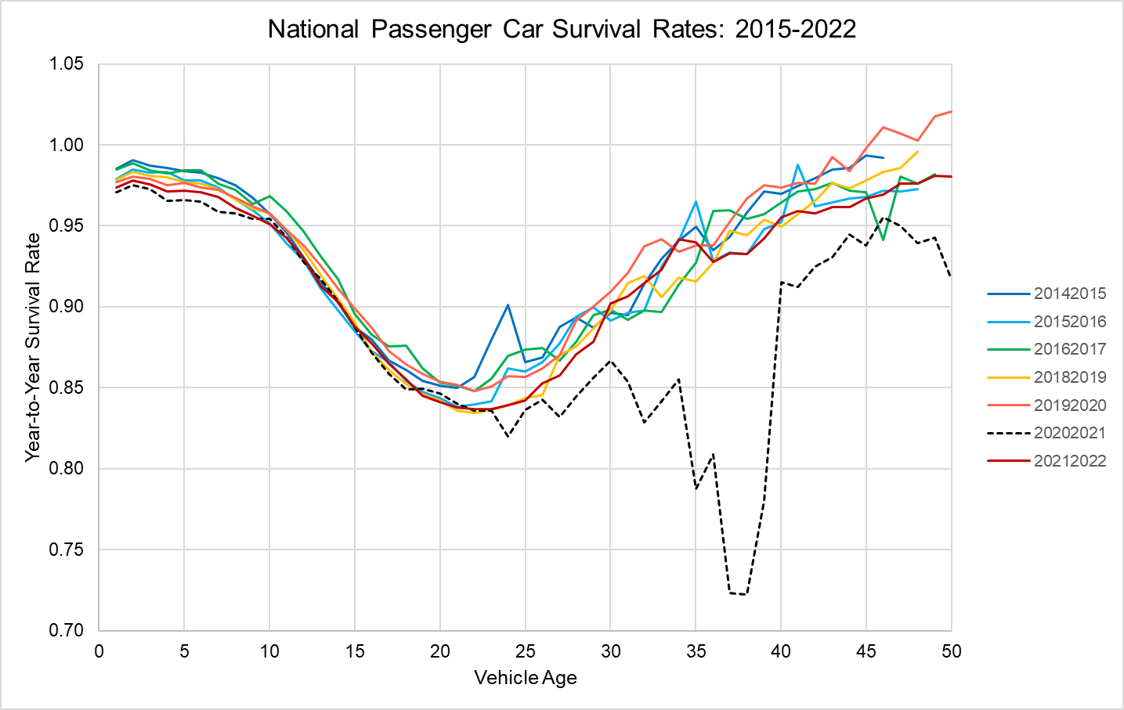
Figure 2. National Passenger Car Survival Rates : 2015-2022.

Initial estimations of the survival functions were made including all data points for the sample described above, even the data points that graphical analysis suggested were outliers (see Figures 3-5). For the final estimations, observations with residuals greater than 0.35 in the initial estimation were dropped from the sample. The value of 0.35 is 7.5 to 10 times the estimated standard errors of the regressions including all data points. Increasing the cutoff to 0.45 did not affect the estimated values of the continuous variables until the third decimal place. Such a large value for screening outliers was chosen because of the increasing variances of residuals with vehicle age. Out of 9,200 total observations for each vehicle type, this resulted in dropping 9 observations for cars, 5 for SUVs and vans, and 103 for pickup trucks. The distribution of all residuals from the Passenger Car, SUV and Pickup Truck models, including outliers and vehicles older than 40 years, are shown in Figures 3-5.
The stepwise regression results discussed in the previous section indicated that the effects of economic and especially demographic variables were weaker for vehicles older than 25 years. We “depreciated” the effects of the continuous variables with vehicle age by multiplying them by 0.9^{age}. We experimented with values of 0.95 and 0.85 and found that 0.9 produced the best fit to the data. We emphasize that because we tested several versions of regression models before settling on the version presented below, significance levels and p values cannot be interpreted as hypothesis tests, but rather only as measures of the strength of correlation with the dependent variable in the final model.
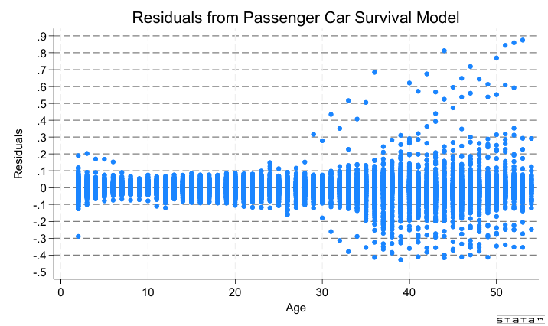
Figure 3. Residuals from the State Passenger Car Net Survival Model
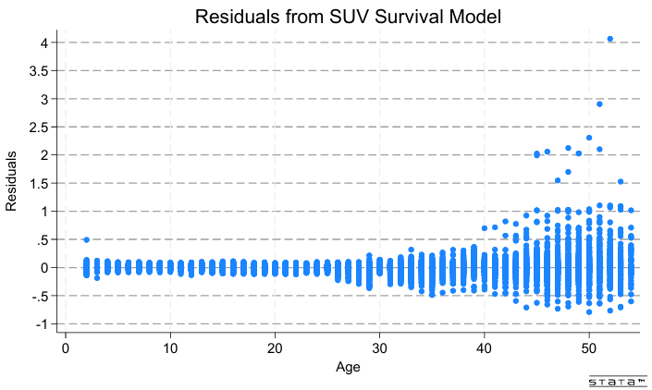
Figure 4. Residuals from the State SUV and Van Net Survival Model
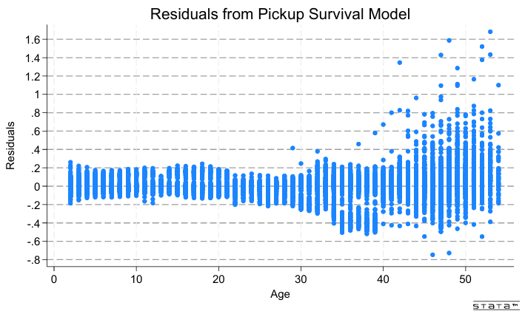
Figure 5. Residuals from the State Pickup Truck Net Survival Model

- Results
The three state net survival models for passenger cars, SUVs & vans, and pickups were estimated using the STATA™ “regress” ordinary least squares (OLS) procedure. Because the variance of residuals increased with age after 25 years, all regressions used the Stata™ “robust” option to account for heteroscedasticity and certain possible misspecification errors. In general, the estimated models statistically explained most of the variance in the survival data, with adjusted R² values and mean square errors of 0.80 and 0.033 respectively for passenger cars, 0.71 and 0.046 for SUVs and vans, and 0.88 and 0.043 for pickup trucks. The residual plots above indicate that the models’ fit to the data is much better for ages up to 25-30 years than for older vehicles.
As expected, higher income and employment growth rates, and greater net migration increased survival rates. Migration into the state as a percent of state population, and the growth rates of state employment and income were statistically significant (again, this is not a valid hypothesis test), except for the income growth rate in the passenger car regression. Net migration into the state proved to be more consistently statistically significant than the rate of population growth. The three continuous variables were statistically significant at the 0.001 level for all three vehicle types except in the passenger car regression in which income growth which was insignificant and net migration was significant at the 0.05 level.
The Stata “testparm” procedure found all the age fixed effects to be significant at the 0.001 level, as were the state, year and COVID fixed effects and the (state)x(log(Age)) interactions as groups.⁹ The Stata “estat vif” procedure calculated variance inflation factors of 1.16 to 2.78 for the continuous variables, indicating that multicollinearity is not a concern for those variables. VIF values for year and COVID fixed effects were also within acceptable levels. As would be expected, state and age fixed effects had VIF values well above 10 (typically 20 to 30), and the VIFs for the age fixed effects increased with increasing age. Such results are typical in regression models when there are a large number of fixed-effect coefficients, and are generally not concerning.
Coefficient estimates for Employment, Income, Migration and the indicator variable for Tennessee in 2015 are shown in Table 2 for the Full Model and with individual fixed effects removed. In the Full Model, all four variables are significant at the 0.001 level with the exceptions of Income (nonsignificant) and Migration (p = 0.05) in the Passenger Car model.⁹ Removing the Year FE has the greatest impact on the significance and signs of the estimates (except for TN2015) because Year represents the national impacts of changes in those variables, as well as other variables, such as prices, that change over time. When Year FEs are included the income and demographic variables represent state differences in those variables from the national trends. When the Year FEs are removed, the correlations of the variables with the national trends affect their coefficient estimates, resulting in reduced statistical significance and a few sign changes, for example, the statistically significant negative effect of employment in the -Year FE alternative specification. The impacts of removing the State fixed effects are small because the model still includes the natural log of age interacted with the State FEs, which adjust to absorb most of the effect of the State FEs. Of all the FEs, removing the Age FEs has the greatest impact on the R² values because the Age FEs describe the national tendency for Survival rates to vary with vehicle age. Removing the COVID FEs also has a large impact on R² because the survival rates for older vehicles during 2021 were so different from those of other years. Removal of the COVID FEs also magnifies the coefficients of the economic variables because of COVID’s effect on the economy and many other aspects of society in 2021.
Table 2. Coefficients of the State Survival Model and the Impacts of Fixed Effects.
Variable | Full Model | Alternative Specifications
 |  | -Year FE | -State FE | -Age FE | -COVID FE
Age | X | X | X |  | X
State | X | X |  | X | X
Year | X |  | X | X | X
COVID | X | X | X | X
Passenger Cars
Employment | 0.344*** | -0.122** | 0.610*** | 1.749*** | 1.162***
Income | -0.020 | 0.078*** | 0.225*** | 0.827*** | 0.369***
Migration | 0.141* | 0.094 | 0.295*** | 0.311** | 0.289***
TN2015 | 0.318*** | 0.325*** | 0.323*** | 0.311*** | 0.289***
R² | 0.795 | 0.787 | 0.761 | 0.438 | 0.729
RMSE | 0.033 | 0.034 | 0.036 | 0.055 | 0.038
SUVs and Vans
Employment | 0.919*** | -0.232*** | 0.882*** | 2.091*** | 1.850***
Income | 0.285*** | 0.039 | 0.383*** | 0.986*** | 0.727***
Migration | 0.236*** | 0.048 | 0.322*** | 0.380*** | 0.404***
TN2015 | 0.331*** | 0.339*** | 0.336*** | 0.331*** | 0.331***
R² | 0.711 | 0.695 | 0.680 | 0/521 | 0.623
RMSE | 0.046 | 0.047 | 0.048 | 0.059 | 0.052
Pickups
Employment | 1.377*** | -0.325*** | 1.351*** | 1.802*** | 4.831***
Income | 0.430*** | -0.097*** | 0.470*** | 0.688*** | 2.070***
Migration | 0.347*** | 0.084 | 0.336*** | 0.397*** | 0.974***
TN2015 | 0.302*** | 0.304*** | 0.305*** | 0.302*** | 0.304***
R² | 0.877 | 0.859 | 0.868 | 0.842 | 0.603
RMSE | 0.043 | 0.096 | 0.044 | 0.048 | 0.077

The results indicate important differences in net survival rates across states that could be used to construct a state-level used vehicle model. The estimated state net survival functions by vehicle type for Alabama, Alaska, Arizona, Arkansas and California in 2022 are illustrated in Figures 6-8. Showing all states, vehicle types and ages would be excessive, so we created a spreadsheet with three worksheets containing the results for each vehicle type. In each worksheet the curves for any state and year can be brought up by entering the state abbreviation (e.g., AL for Alabama) and year (e.g., 2021 for 2020 to 2021). Five states can be graphed at one time, as in the graphs below. Each Figure shows five states, in alphabetical order by state postal code abbreviation. The graphs show both the annual survival rates and cumulative survival, the cumulative product of the annual rates. While many states’ functions are similar, some important differences are evident. Some states appear to be importers of younger used vehicles, with survival rates close to or exceeding 1.0, while other states appear to be exporters with unrealistically low survival rates for 3-10-year-old cars. The cumulative rates give a clearer picture of how many vehicles are being imported or exported by a state. The cumulative curves must be interpreted with caution because they assume that the conditions existing in the year in question will continue indefinitely, which is obviously not the case. While there are some kinks in the annual rates, the effects are smoothed out considerably in the cumulative curves. Detailed examination of the state data indicates that the kinks in the estimated curves are not artifacts of the estimation but reflect the empirical data.
For most states, annual survival rates begin between 0.95 and 1.00 for 2-year-old vehicles and decline relatively slowly until about ten years of age, after which survival rates decrease more rapidly. The decline slows approaching 20 years and reverses, increasing after about 22 years. Increasing survival rates (decreasing scrappage rates) for older vehicles were observed at the national level by Greene and Leard (2024a). The consistency in this pattern across states is partly attributable to the age fixed effects of the imposed model structure. However, the model allows state-specific effects of the logarithm of age that can shorten or lengthen the time when survival rates begin to increase.
Annual and cumulative net survival curves for the first five states (alphabetically) are compared for the three vehicle types and years 2022 and 2018 in Figures 6-11. Cumulative net survival rates are the cumulative product from 2, to 40 years of annual survival rates, assuming the conditions in 2022 continued. In that sense, they are hypothetical because when conditions change in 2023, annual net survival will change, altering the cumulative rates in that year. The cumulative curves represent what would happen if the given year’s rates persisted for 40 years, but in reality, they will change. In 2022, the annual passenger car net survival curve for Cars in Alabama is slightly above 1.0 for ages 2 to 5, implying a net immigration of cars of relatively new used cars into the state (Figure 6). The effect is amplified in Alabama’s cumulative net survival curve as the immigration of vehicles accumulates in the on-road stock, reaching about 6 percent above initial new car sales. Again, note that the cumulative curves describe what would happen in Alabama if the rates in calendar year 2022 persisted indefinitely, but in fact they will change in the future.
In contrast, California’s 2022 annual net survival curve for Cars is lower than the other states until age 6, when it begins to cross over the other states’ curves. Its cumulative curve is substantially below the others as the effect of the outflow of newer used vehicles accumulates. By age 17, California’s cumulative survival curve is above the other states’, implying that cars last longer in California or that there is a net immigration of older cars to California, or both. As age increases, the cumulative survival curves of the other four states tend to converge somewhat, while California’s crosses over the others and diverges.
The same states’ 2018, pre-pandemic curves for passenger cars are similar to the 2022 curves. Survival rates for all states are slightly higher, but the difference is not obvious to the eye.
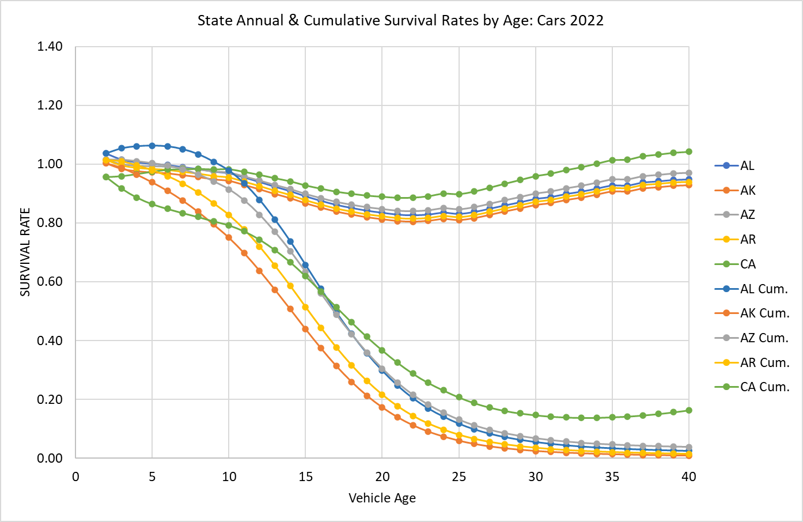
Figure 6. Predicted Annual and Cumulative Survival Rates by Age for Five States: Cars 2022

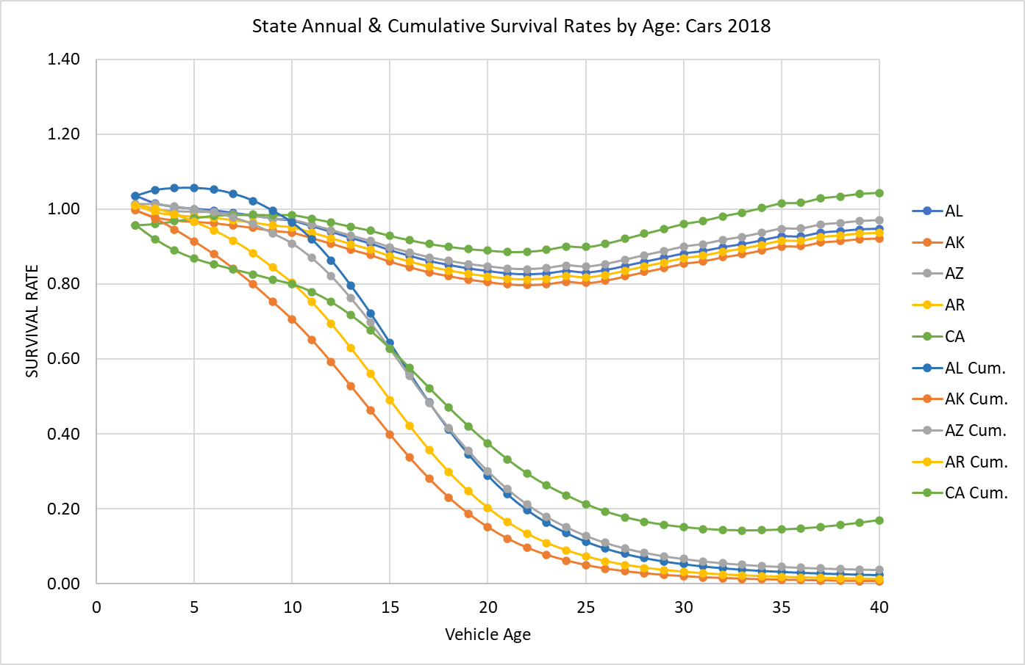
Figure 7. Predicted Annual and Cumulative Net Survival Rates by Age for Five States: Cars 2018
Estimated net survival curves for SUVs and vans in the same five states indicate a greater inflow of newer used SUVs and vans to Alabama, Arizona, and Arkansas. The differences between 2022 and 2018 are greater. There is a greater immigration of SUVs and vans in 2018, with net survival rates greater than 1.0 persisting to age 10 in Alabama and Arizona. Although cumulative net survival rates in the five states tend to converge in 2022 as the SUVs and vans age, that is not the case for the 2018 curves. Again, the cumulative survival curves are constructed by assuming that the annual net survival rates will persist, which is not realistic.
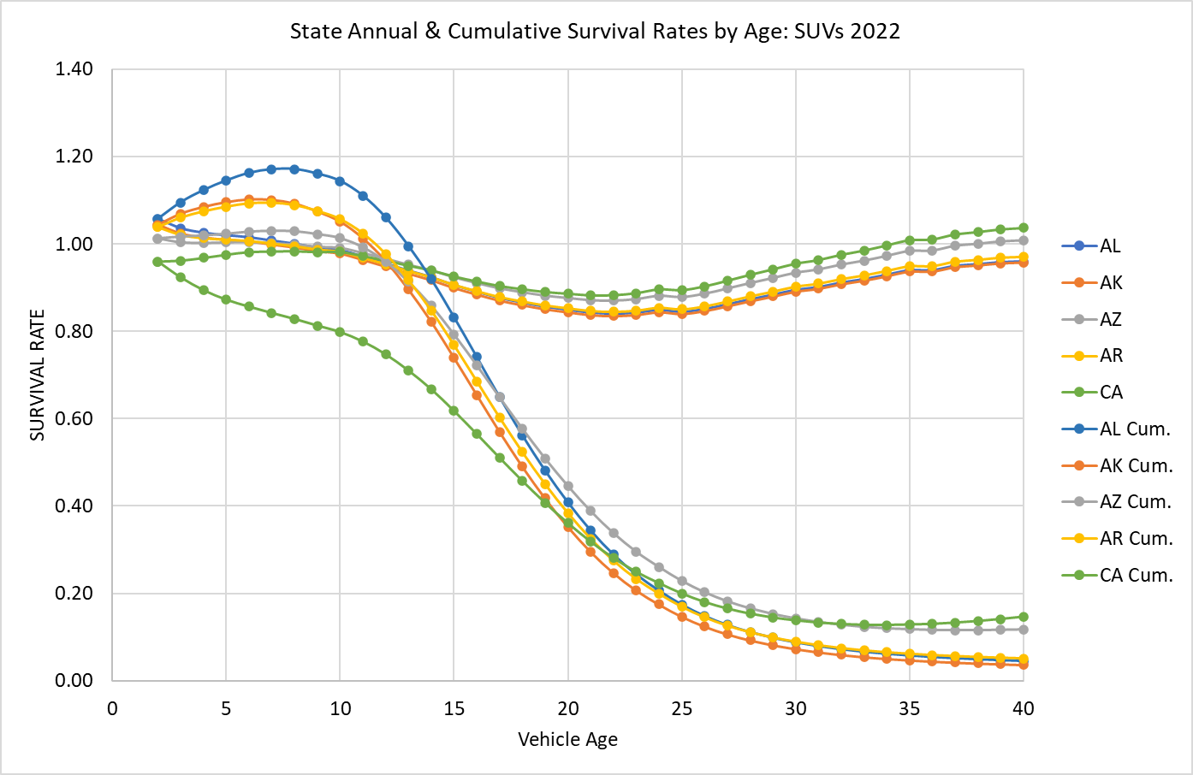
Figure 8. Predicted Annual and Cumulative Net Survival Rates by Age for Five States: SUVs and vans 2022
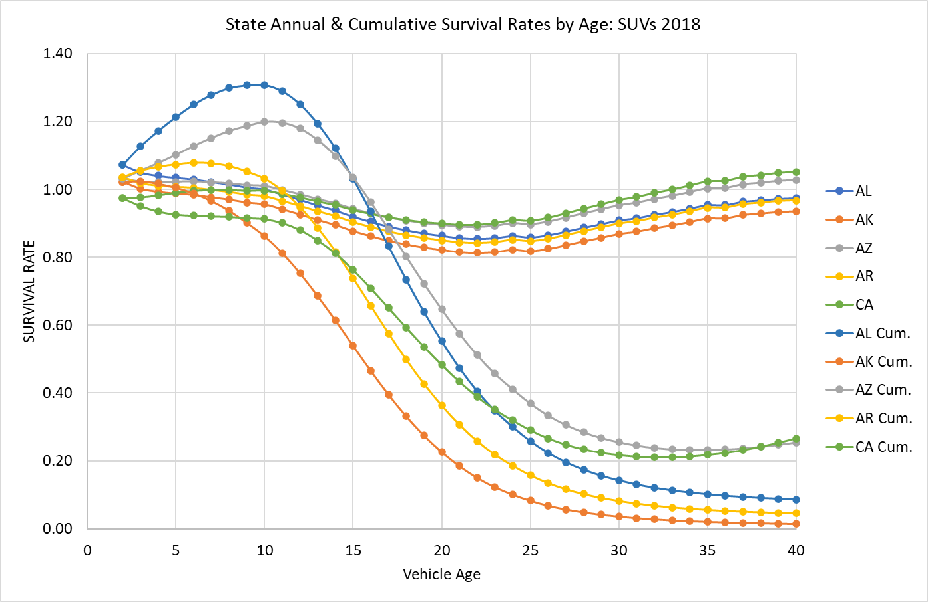
Figure 9. Predicted Annual and Cumulative Net Survival Rates by Age for Five States: SUVs and vans 2018
Pickup trucks are different. There are fewer of them. A larger fraction is used for commercial purposes including farming, but over time their popularity for everyday household transportation has increased, especially in southern and western states, where pickup trucks have traditionally been more popular. The sunbelt states have seen rapid population growth since 2010, From 2010 to 2020, the populations of the Northeast and Midwest grew by 4.1% and 3.1%, respectively, while those of the West and South grew by 19.2% and 10.2%, respectively (U.S. Census, 2024). This continues a decades long pattern of migration that was interrupted by the COVID pandemic. Estimates for 2022 show New York and Illinois as donor states for pickups, with low net annual survival rates and correspondingly lower cumulative net survival rates. These patterns can be seen in Figures 10 and 11 that illustrate net survival curves for Texas, Mississippi, Iowa, Illinois and New York for 2022 and 2018. Pickups emigrated from states like Illinois and especially New York and immigrated to sunbelt states like Mississippi and Texas, and agricultural states like Iowa.
In Figure 12, we show the 2018 pickup curves without the effects of growth of employment and income and assuming no population migration. While there are still differences among the states due to state fixed effects and the interaction of state and the log of age, the differences are greatly diminished. Even without the demographic and economic effects, there are differences among states that cause differences in net survival rates. Some of the causes may be due to variables including car owners’ preferences that we did not include in our model that will change from year to year. However, due to the nature of fixed effects, it is likely that most are factors like population density or the state’s economic base that change slowly. In either case, the marked changes in net survival rates indicate that the included economic and demographic variables statistically explain a large fraction of the variation in state net survival rates.
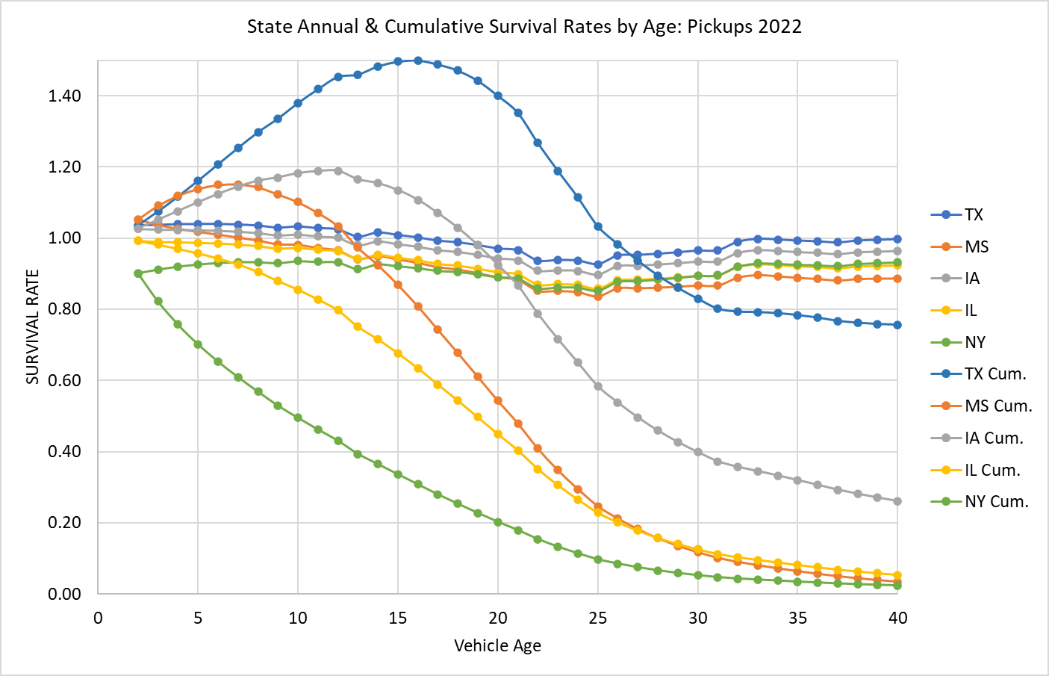
Figure 10. Predicted Annual and Cumulative Net Survival Rates by Age for Five States: Pickups 2022
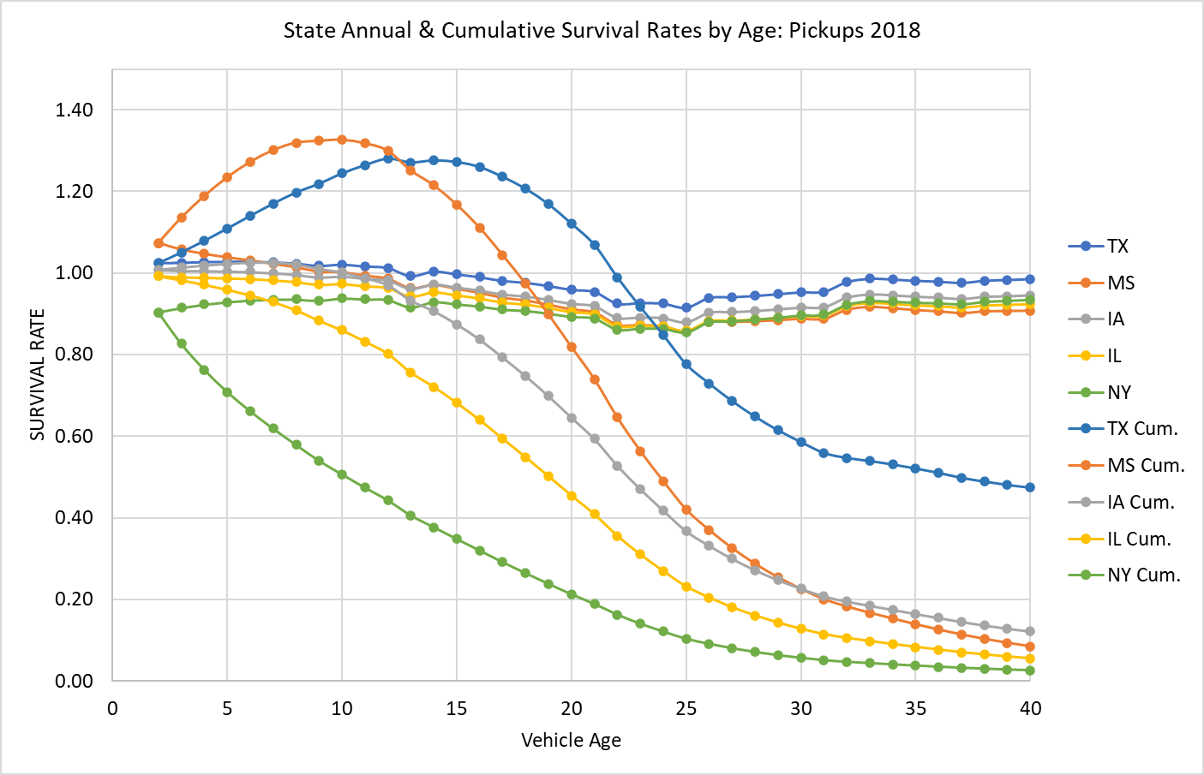
Figure 11. Predicted Annual and Cumulative Net Survival Rates by Age for Five States: Pickups 2018
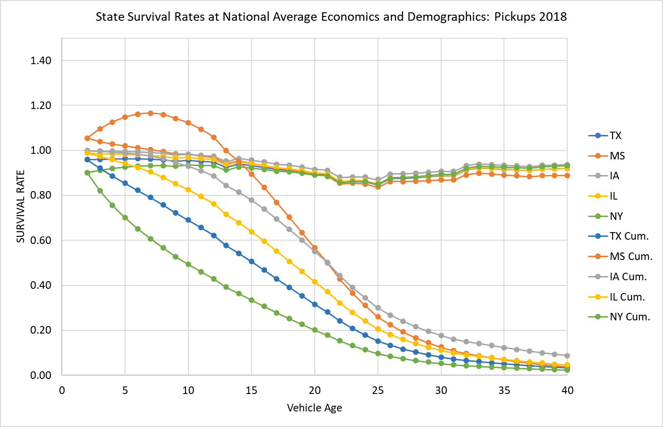
Figure 12. Predicted Annual and Cumulative Net Survival Rates Assuming National Values of Economic and Demographic Variables: Pickups 2018

We reiterate that the cumulative survival curves are hypothetical and assume that the net annual survival rates in the years shown will persist of the lifetimes of the pickup trucks. In fact, economic conditions and demographic patterns will change. To illustrate this point, Figure 13 shows that estimated net survival curves for the same states for the peak pandemic year of 2021. The unprecedented changes caused by the global pandemic did not continue even into 2022.

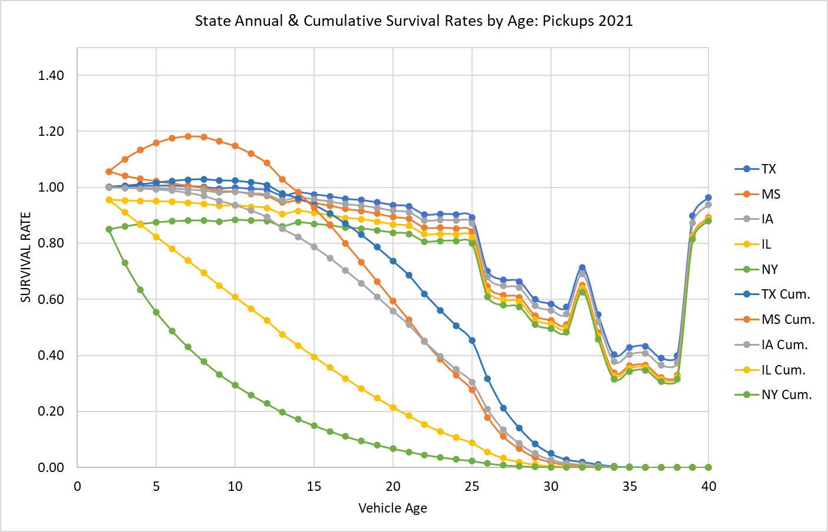
Figure 13. Predicted Annual and Cumulative Net Survival Rates by Age for Five States: Pickups 2021

- Discussion: Potential for State Level Forecasting and Analysis
The three state-level survival models described above could become building blocks of a state level UVM, given state level data on vehicles in operation by age and vehicle type for a base year, state level demographic and economic projections for future years, and a method of estimating used vehicle prices and their effects on vehicle survival, such as outlined in the Introduction. This section describes how such a model could be designed using the estimated state survival functions. Challenges to constructing a full state-level used vehicle model are discussed in the following section.
Because the state survival models contain numerous fixed effects, it is necessary to decide which fixed effects will be used for forecasting. The state and age fixed effects represent the average fixed effects over the period on which the model was estimated (2016-2022). This is also true of state and log of age interaction coefficients, as well as the coefficients of employment, price and state migrations. All these coefficients are assumed to be constant during the forecast period. The COVID effects, on the other hand, should be omitted, assuming a future pandemic is not being forecasted. The year fixed effects, however, represent the impacts of unobserved factors. Because of this, it is not necessarily best to use the year effect of the final year, 2022, although that is a plausible assumption. One alternative would be to average the year fixed effects, omitting the COVID year of 2021. Once that is decided, the resulting coefficient values constitute the base year survival model.
The first step is to calibrate the UVM to a given baseline forecast of new vehicle sales that is intended to represent an equilibrium of new and used vehicle supply and demand. Calibration would adjust for two types of changes: 1) changes in the generalized cost (or value) of new vehicles relative to the base year and, 2) changes in demographic and macro-economic factors that may shift the demand function for used vehicles. That is, the demand for used vehicles is assumed to respond to changes in the price of new vehicles (their closest substitute good) and changes in the number of consumers and their income. This requires estimates of price and income elasticities. The UVM need not explicitly equilibrate supply and demand if it uses price elasticity estimates consistent with an equilibrium of new and used vehicle sales to estimate changes in scrappage rates following the method of Jacobsen et al. (2021).
Not only the changes in used vehicle price, but subsidies and monetized changes in their utility can affect the survival rates of used vehicles. For example, the value of public charging infrastructure for EVs could be estimated and the effects on net survival rates estimated (Greene et al., 2020; Burra et al., 2024). Let δ_{ivat} be the change in the cost of a vehicle in state i, of age a, type v, in year t due, for example, to a tax, subsidy or monetizable attribute, while Δ_{ivat} is the change in used vehicle price due to changes in new vehicle price. The percent change in generalized cost can be multiplied by the price elasticity of vehicle scrappage to estimate the new scrappage (or survival) rate.
$r_{ivat}^{*}=r_{ivat}\left[1+\left(\frac{Δ_{ivat}+δ_{ivat}}{p_{ivat}}\right)α\right]= r_{ivat}+α\frac{Δ_{ivat}+δ_{ivat}}{p_{ivat}}r_{ivat}$ (3)
Equation (3) requires an estimate of the price of an a-year-old used vehicle, p_{a}, to calculate the relative change in price. Used vehicle prices can be estimated by multiplying the price of a new vehicle from the new vehicle sales forecast by an empirically estimated exponential depreciation function (Hawley, 2024). Estimating used vehicle prices with a constant depreciation function is only an approximation to the market equilibrium price. However, since its purpose is to scale the change in generalized cost, an approximation that incorporates the chief determinant of the prices of older vehicles, depreciation with vehicle age, should give reasonably accurate results.

- Challenges in Developing a State-Level Used Vehicle Model
Developing a state-level model of the used vehicle market by vehicle age, vehicle type and powertrain type is a new challenge. We have developed state and regional models using constant survival rates, but we are not aware of any models with price and policy sensitivity at this level of detail. Even given an appropriate UVM modeling framework and valid state-level survival functions, several challenges to constructing a theoretically sound, practical state level model remain.
The state level net survival models imply that there are substantial movements of used vehicles from state to state. These may be vehicles that move with owners who migrate or vehicles that are sold to new owners in other states. The models also suggest that state scrappage rates likely differ, which might also affect the trading of used vehicles among states. The UVM was not designed to estimate a market equilibrium across states including trade in used vehicles. The data available do not directly measure such trading. The data do not include flows of used vehicles from one state to another, but only the net effect of such flows combined with differences in scrappage rates on net survival rates. If the patterns of flows are relatively stable over time, or if population and employment variables satisfactorily capture changes over time, the existing model formulation should produce reasonably accurate estimates of future used vehicle migrations. However, it may also be desirable to impose some restrictions on the projected state flows to ensure that used vehicles are not newly created or excessively destroyed. For example, neglecting international movements of used vehicles, the sum of the total counts of state differences from national scrappage by vehicle type and year, must sum to zero. However, whether it is useful or important to constrain state net vehicle scrappage with a national function is not clear at present.
The research completed to date indicates that it is possible to construct useful state survival and scrappage models for the three vehicle types. Effectively modeling the transition to zero emission vehicles will require separately modeling them, and probably distinguishing between all-electric, plug-in electric and perhaps fuel cell and hybrid electric vehicles. Because mass-produced plug-in vehicles are a relatively recent phenomenon, it is not possible to empirically estimate complete survival functions for them. It will probably be necessary to use modified versions of the functions estimated in this report.
Although several challenges to developing a comprehensive state level used vehicle model remain, none appear to be insurmountable.

- References

- Alberini, A., M. Bareit, M. Filippini, A.L. Martinez-Cruz, 2018. “The impact of emissions-based taxes on the retirement of used and inefficient vehicles: The case of Switzerland”, Journal of Environmental Economics and Management, 88: 234-258.
- Alliance for Automotive Innovation (AAI), 2025. “Get Connected: Electric Vehicle Quarterly Report”, Third Quarter 2024. https://www.autosinnovate.org/posts/papers-reports/get-connected-q3-2024 .
- Bento, A., K. Roth and Y. Zuo, 2018. “Vehicle Lifetime and Scrappage Behavior: Trends in the U.S. Car Market”, The Energy Journal, 39(1): 159-183.
https://www.researchgate.net/publication/322177636_Vehicle_Lifetime_Trends_and_Scrappage_Behavior_in_the_US_Used_Car_Market
- Burra, L., M. Kasawaneh and C. Cirillo, 2024. “Impact of charging infrastructure on electric vehicle adoption: A synthetic population approach”. Travel Behaviour and Society, 37 (2024). https://doi.org/10.1016/j.tbs.2024.100834 .
- Cox Automotive, 2021. “Commentary: Independent Dealers are Poised to Thrive as Driving Force in Recovery”, https://www.coxautoinc.com/market-insights/commentary-independent-dealers-are-poised-to-thrive-as-driving-force-in-recovery/ .
- Cramer, J., 1958. “The Depreciation and Mortality of Motor-Cars”, Royal Statistical Society. Journal. Series A: General, 121(1): 18–46. https://doi.org/10.2307/2342989 .
- Federal Highway Administration (FHWA), 2023. Traffic Volume Trends December 2023. https://www.fhwa.dot.gov/policyinformation/travel_monitoring/23dectvt/23dectvt.pdf .
- Greene, D.L. and B.P. Leard, 2024a. “Trends in scrappage and survival of U.S. light-duty vehicles”, Transportation Research A: Policy and Practice, 180: https://doi.org/10.1016/j.tra.2024.103982 .
- Greene, D.L. and B.P. Leard, 2024b. “MA3T Used Vehicle Model Documentation”, unpublished manuscript of March 27, 2024, available from the authors. Baker School of Public Policy and Public Affairs, University of Tennessee, Knoxville, TN.
- Greene, D.L. and B.P. Leard, 2024c. “Enhancements to the ORNL MA3T Used Vehicle Model to Enable Analysis of Taxes, Subsidies and Other Policies Directed at Used Vehicles”. Unpublished project report, available from the authors, Baker School of Public Policy and Public Affairs, University of Tennessee, Knoxville, TN.
- Greene, D., E. Kontou, B. Borlaug, A. Brooker, M. Muratori, 2020. “Public charging infrastructure for electric vehicles: What is it worth?”, Transportation Research D, vol. 78: 102182, https://doi.org/10.1016/j.trd.2019.11.011 .
- Greenspan, A. and D. Cohen, 1999. “Motor Vehicle Stocks, Scrappage and Sales”, Review of Economics and Statistics, 81(3): 369-383.
https://www.jstor.org/stable/2646761?seq=1
- Hawley, R.E., 2024. “”Car depreciation: What it is and how it works”, Bankrate. https://www.bankrate.com/insurance/car/understanding-car-depreciation/ .
- Jacobsen, M., R. Beach, C. Cowell, and J. Fletcher, 2021. “The Effects of New-Vehicle Price Changes on New- and Used-Vehicle Markets and Scrappage”, EPA-420-R-21-019, U.S. Environmental Protection Agency, Office of Transportation and Air Quality, https://cfpub.epa.gov/si/si_public_record_Report.cfm?dirEntryId=352754&Lab=OTAQ .
- Jacobsen, M.R. and A.A. van Bentham, 2015. “Vehicle Scrappage and Gasoline Policy”, American Economic Review, 105(3): 1312-1338.
https://scholar.google.com/citations?view_op=view_citation&hl=en&user=2gqWO3sAAAAJ&citation_for_view=2gqWO3sAAAAJ:IjCSPb-OGe4C
- Leard, B. and D. Greene, 2023. “Coordinating the Electric Vehicle Transition and Electricity Grid Decarbonization in the U.S. is Not Essential to Achieving Substantial Long-Term Carbon Dioxide Emissions Reductions”, Environmental Research Letters, 18(7), 074035. https://iopscience.iop.org/article/10.1088/1748-9326/acdd85 .
- Lin, Z., D. Greene and J. Ward, 2025. User Guide of the ORNL MA3T Model (V20130729). Available at teem.ornl.gov/ma3t.shtml .
- Parks, R., 1977. “Determinants of Scrapping Rates for Postwar Vintage Automobiles”, Econometrica, 45(5), 1099-1115.
https://www.jstor.org/stable/1914061
- U.S. Census Bureau, 2024a. State-to-State Migration Flows. “Table 1. State-to-State Migration Flows¹: 2023 American Community Survey 1-Year Estimates” by year, 11/2024. https://www.census.gov/data/tables/time-series/demo/geographic-mobility/state-to-state-migration.html .
- U.S. Census Bureau, 2024b. “State Population Totals and Components of Change: 2020-2023”, and “Annual Estimates of the Resident Population for the United States, Regions, States, the District of Columbia, and Puerto Rico: April 1, 2010, to July 1, 2019; April 1, 2020; and July 1, 2020”. https://www.census.gov/data/tables/time-series/demo/popest/2020s-state-total.html .
- U.S. Census Bureau, 2024c. “Historical Population Change Data (1910-2020”. https://www.census.gov/data/tables/time-series/dec/popchange-data-text.html .
- U.S. Bureau of Economic Analysis (BEA), 2024. Regional Data: GDP and Personal Income, “SASUMMARY State annual summary statistics: personal income, GDP, consumer spending, price indexes, and employment”, https://apps.bea.gov/itable/?ReqID=70&step=1#eyJhcHBpZCI6NzAsInN0ZXBzIjpbMSwyOSwyNSwzMV0sImRhdGEiOltbIlRhYmxlSWQiLCI2MDAiXSxbIk1ham9yX0FyZWEiLCIwIl1dfQ== .
- U.S. Department of Transportation, Bureau of Transportation Statistics, National Transportation Statistics 2025. https://www.bts.gov/topics/national-transportation-statistics , tables 1-11, 1-40 and 1-50
- Walker, F., 1968. “Determinants of Auto Scrappage”, Review of Economics and Statistics, 50(4): 503- 506.

Appendix A. State Vehicle Survival Model Estimation Results
Passenger Cars

SUVs and Vans

Pickups

Appendix B. Graphs of State Level Cumulative Survival Rates by Vehicle Type: 2018 to 2019.
The following graphs were created by Arthur Yip of the National Renewable Energy Laboratory to determine whether state scrappage rates varied across states and differed from national rates. The graphs reveal some striking differences. Some consistency is evident by state across the three vehicle types. States like Idaho, that have unusually high survival rates for newer used passenger cars, also have high survival rates for new SUVs and pickup trucks. The graphs provided the first evidence of systematic differences in survival rates among states.
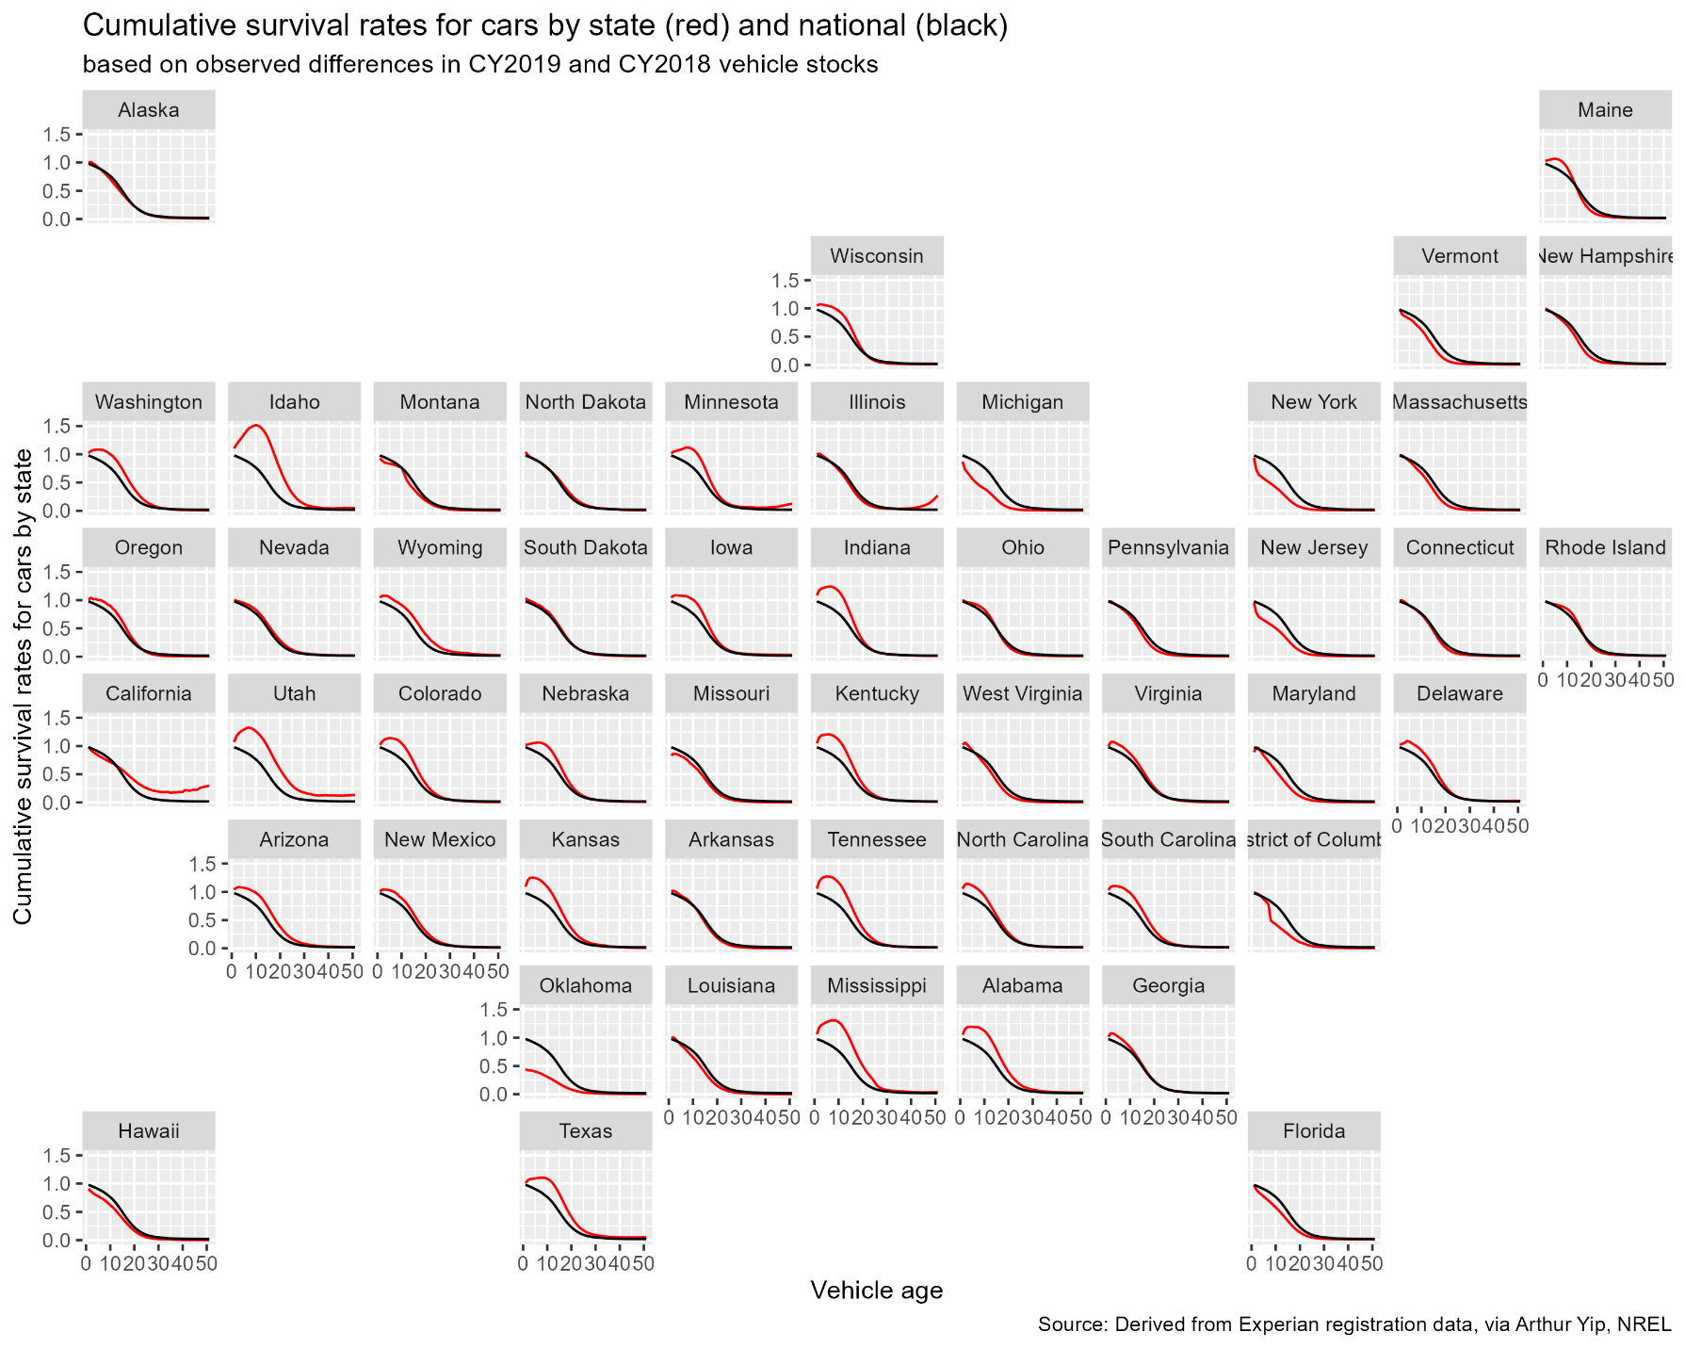
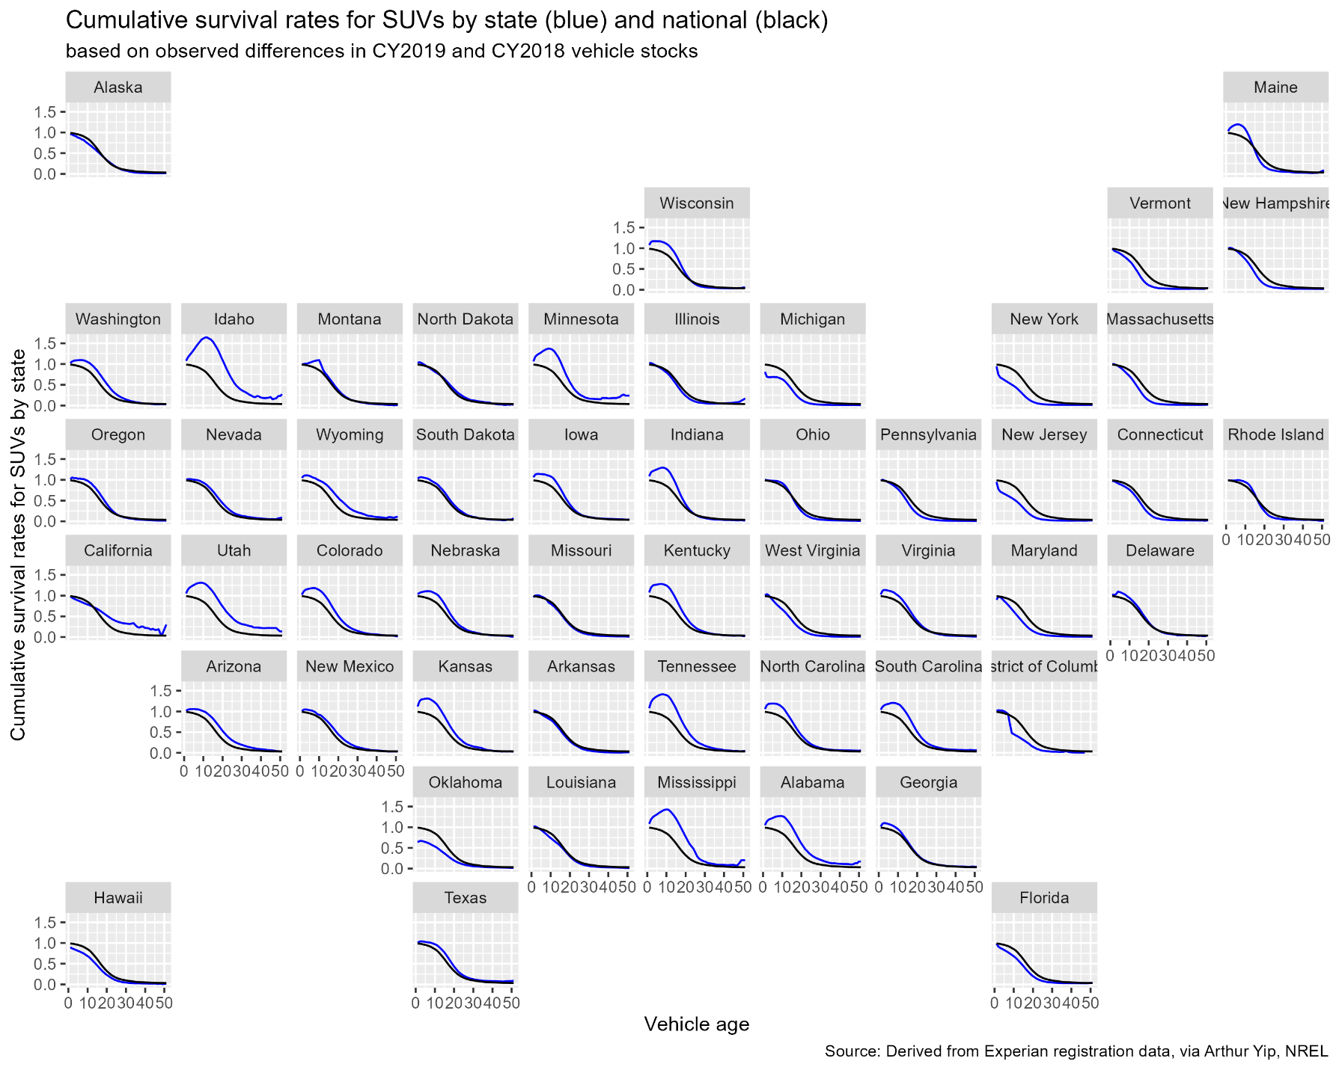
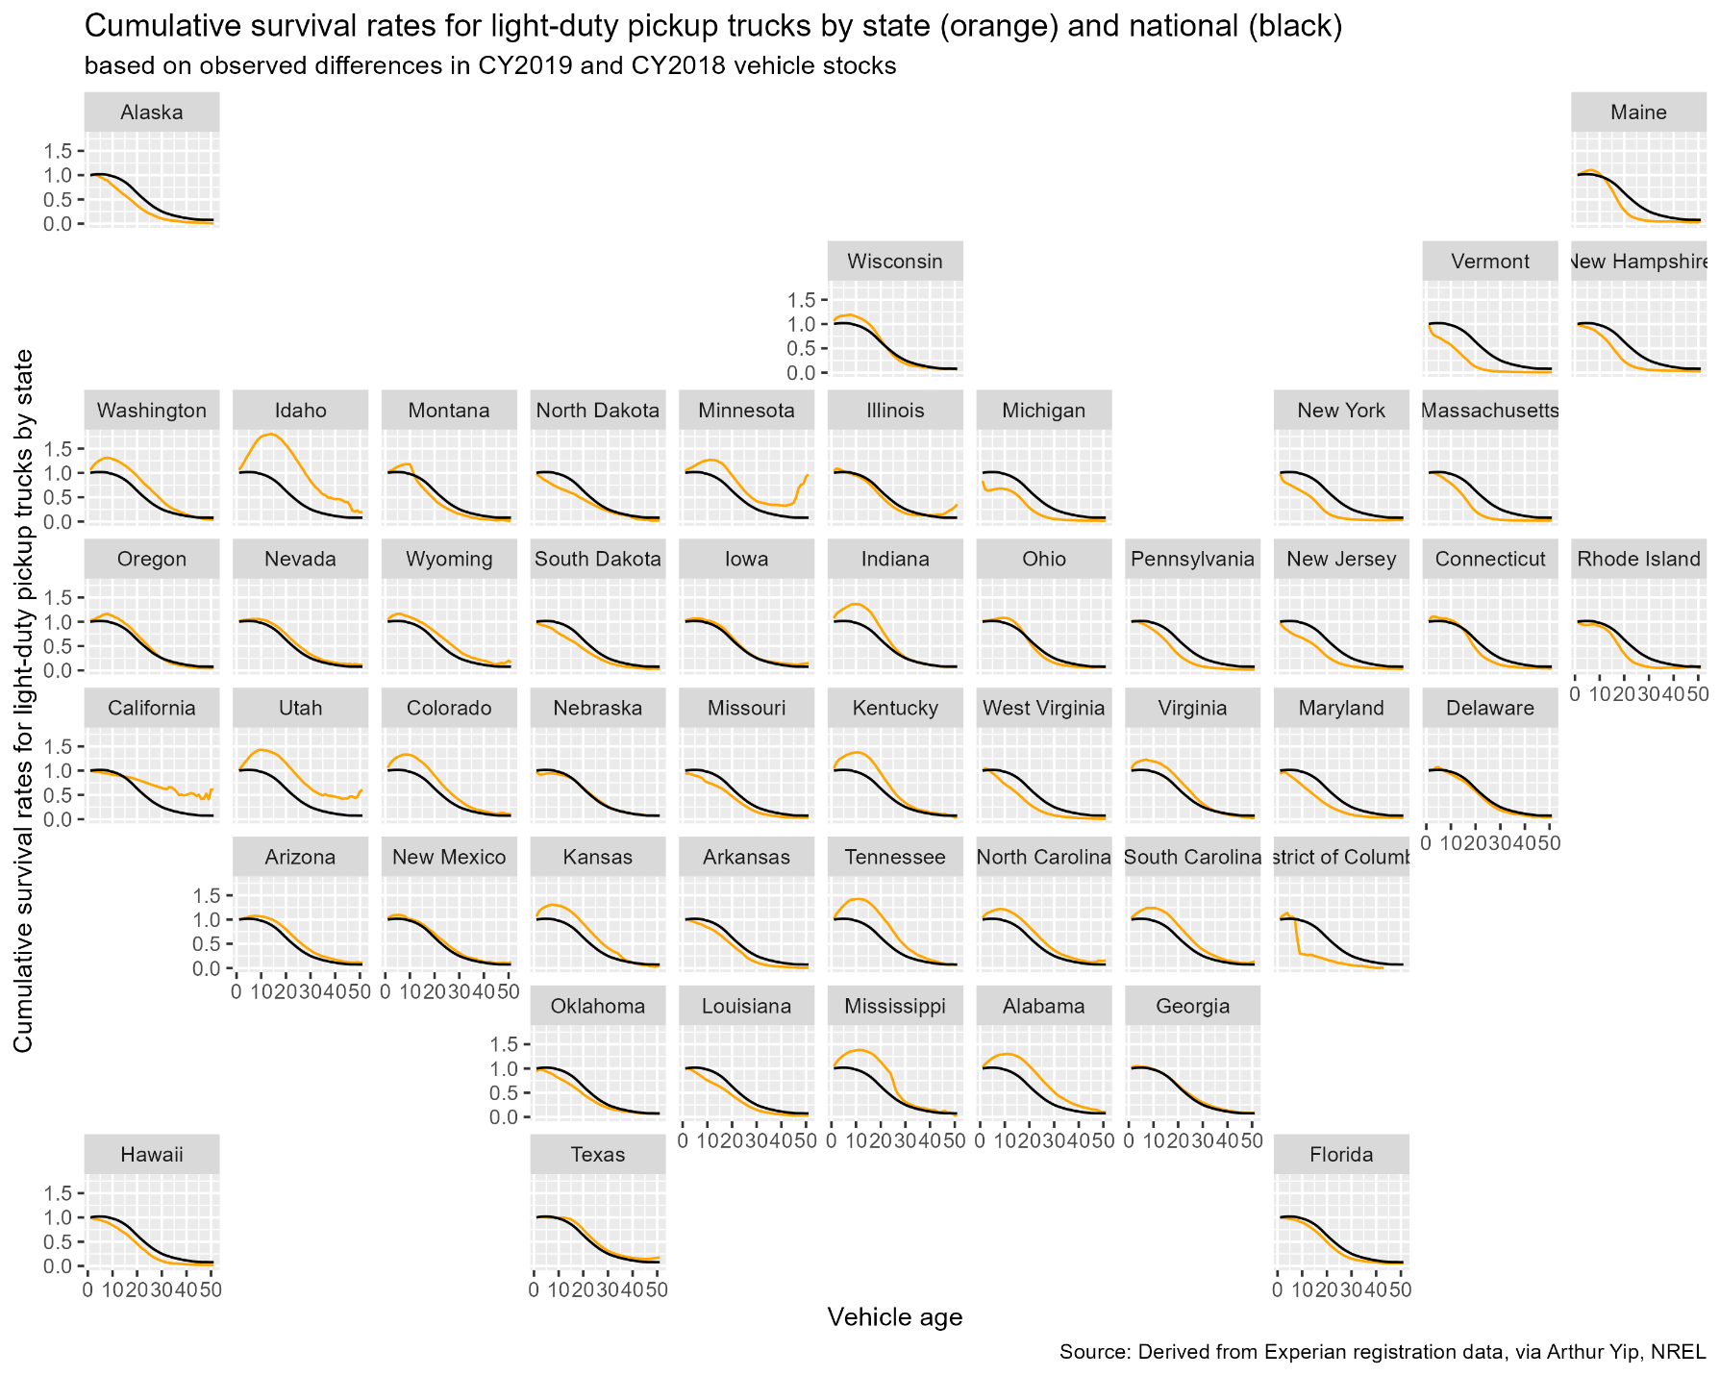

This research was supported by Oak Ridge National Laboratory. The content of this report reflects the views of the authors and does not necessarily represent the views of the University of Tennessee, Oak Ridge National Laboratory, National Renewable Energy Laboratory, or the Department of Energy.
The new vehicle sales model referred to is is the Market Acceptance of Advanced Automotive Technologies Model (MA3T), developed by Oak Ridge National Laboratory (Lin et al., 2025). Recent enhancements to include used vehicles at the national level are described in Greene and Leard (2024b, 2024c).
We hypothesize that the willingness to offer a vehicle for sale is chiefly a function of transaction costs, vehicle attributes including cumulative wear and tear and the value owners attach to their vehicles, all of which are heterogeneous. Transaction costs are partly monetary costs but also include inconvenience and the risk and uncertainty inherent in purchasing a new and especially another used vehicle.
If U_{i} is the utility of choice alternative i based on its observed attributes, then the generalized value (or generalized cost) of alternative i is (1/λ)U_{i} , where λ is the marginal utility of income with units of utils per dollar.
The total derivative of demand for used vehicles of age a, q_{a}, with respect to the price of new vehicles, p₀, dq_{a}/dp₀, can be written as a sum of partial price elasticities. $\frac{dq_{a}}{dp_{0}}=\frac{∂q_{a}}{∂p_{0}}+\sum_{i}{\frac{∂q_{a}}{∂p_{i}}\frac{∂p_{i}}{∂p_{0}}=}\frac{∂q_{a}}{∂p_{0}}\frac{p_{o}}{q_{a}}+\sum_{i}{\left(\frac{∂q_{a}}{∂p_{i}}\frac{p_{i}}{q_{a}}\right)\left(\frac{∂p_{i}}{∂p_{0}}\frac{p_{0}}{p_{i}}\right)}$ . Thus, if the partial elasticities of the prices for all ages with respect to new vehicle prices are equal, and the sum of the partial cross price elasticities for other ages equals the own price elasticity for age a, the total derivative of q_{a} with respect to p₀ equals the partial derivative with respect to p₀.
The VIN numbers themselves were not included in the data purchased by NREL and thus not available to this study.
A description of the data and sources is available from the lead author.
The age of a vehicle in the available data is calculated as the calendar year minus the vehicle’s model year. Because vehicle model years do not begin on January 1 and end on December 31, but on varying dates, and because not all vehicles of a model year are sold in that model year, counts of 0 and 1-year-old vehicles do not produce meaningful estimates of survival rates and were excluded from the analysis.
Because several model formulations were estimated before settling on the final formulation, significance levels should not be interpreted in the usual way as tests of null hypotheses but rather as indicators of the strength of the correlations between the independent variables and the dependent variable.
An Excel™ spreadsheet allowing all states, years and vehicle types to be graphed 5 at a time is available from the lead author.
Such data exist, but the cost was prohibitive given the budget of our study.

